**Year 5 Week 3 – Day 3** **(Extension)** **Calculate rises and falls in temperature**

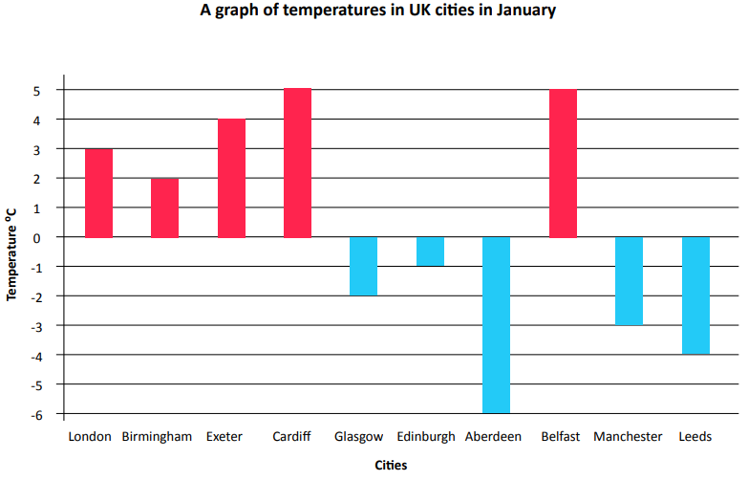**Calculate the differences in temperature**

1. **How much warmer is London than Manchester?**
2. **How much colder is Glasgow than Cardiff?**
3. **Difference between Leeds and Birmingham?**
4. **How much warmer is Exeter than Aberdeen?**
5. **Now make up two questions of your own, using the data from this graph (you will also need to calculate the answer).**