**Barbara Blake-Hannah**

Barbara Blake-Hannah became Britain’s first black female TV reporter back in 1968.

She reported five days a week, on the local news programme.

However, her contract with Thames television came to an end after just nine months, following complaints from viewers about having a black person on their screens. “It broke my heart,’” she says.

Barbara was born and raised in Jamaica where her father was a magazine editor. Her family were quite wealthy, and she was able to go to an elite boarding school. Her father made sure that both black and white people were treated equally and fairly.

She moved to Britain in 1965 and was shocked to find that she was not welcomed by all white people in Britain. She struggled to find somewhere to live but her good education meant she was able to get a job at a newspaper and she made friends easily.

She moved back to Jamaica after losing her job on television.

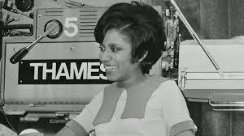

**Sislin Fay Allen**

Sislin Fay Allen became Britain's first black Woman Police Constable (WPC), joining the Metropolitan Police in 1968.

Sislin Fay Allen, was a nurse at Croyden hospital but one day was she saw an advert for male and female police officers in the newspaper. She decided to apply.

At the time there were no black female officers so the mum-of-two sat down and wrote an application. Within a few weeks Sislin had made it to the interview stage, shocking her husband and family when she was accepted.

She said, “People were curious to see a Black woman there in uniform walking up and down, but I had no problem at all, not even from the public. On the day I joined I nearly broke a leg trying to run away from reporters. I realised then that I was a history maker. But I didn’t set out to make history; I just wanted a change of direction.”

In 1972 Sislin left the Metropolitan Police because of family commitments, returning to her husband’s birth country of Jamaica with their children. She joined the Jamaican police force and received a welcoming letter from the then Prime Minister, Michael Manley.

Sislin later returned to the UK with her family and settled in south London.

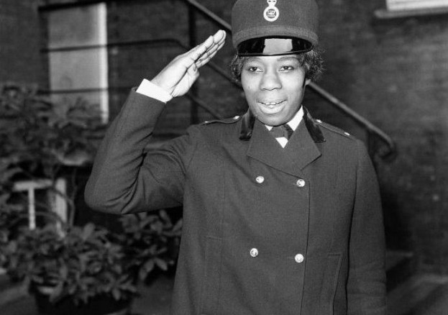

**Diane Abbott**

In 1987 Diane Abbott became the first black woman to be elected as a Member of Parliament (MP).

Diane Abbott was born to Jamaican immigrants in London in 1953. Her father was a welder and her mother a nurse. She attended Harrow County Grammar School for Girls, and then Newnham College, Cambridge, where she studied history.

Diane Abbott has been part of many groups within parliament, making very important decisions.

She is the founder of the London Schools and the Black Child initiative, which aims to raise educational achievement levels amongst black children.

In 2010 she was given a very important job of Shadow Minister for Public Health.

