**Story start - Into the mysterious house.** Study the video clip carefully and write a suitable description for each section. Remember to use short sentences for action and longer sentences for description and explanation. Your focus should be on the description. I have written some notes for guidance but please don’t just copy this.

|  |
| --- |
| **Outside the house** Sally Sparrow wanted to take pictures of an empty house for her art and film project.  It was late at night and a chill winter breeze rustled in the trees.  She crawled over the iron gate (sound of the gate rattling), ignoring the sign that read BEWARE – NO ENTRY.  There was the screech of a fox as she approached the shadowy house (no mentions of ghosts please!) |
| **Entering the house** Sally broke down the rotten door and crawled though.  She pulled away the ivy and tree roots that were in her way |
| **Exploring** Sally explored the ancient hallways and rooms. Cobwebs clung to pictures and chandeliers.  Kneeling, to peer more closely, she took photographs for her project book. |
| **Peeling the wallpaper** Looking up, she saw some peeling wallpaper revealed some writing.  Curious, Sally tugged at the paper and it pulled away easily from the damp walls to reveal more writing. It was a message.  ‘Beware Sally Sparrow’  Why was the writing there and how could anyone have known that she was going to peel that paper away from the wall? Was the message a warning for Sally? |
| **The Weeping Angel** Shaken, Sally looked around the room. It all looked more sinister now.  It was then that she saw the stature on the other side of the shattered window. It hadn’t been there before - had it?  Why was it covering its eyes? |

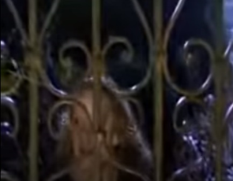**Example story start - Into the mysterious house.**

Sally grappled with the rusty gate and clambered over and into the shadowy garden. The sign read ‘BEWARE – NO ENTRY’’

Sally smiled – no one was going to win a photography prize unless risks were taken and the old, derelict, ‘Smiths House’ was too good an opportunity for this budding reporter to miss out on.

A fox screamed into the night. Sally froze. What was that movement behind the trees? Was it just her imagination?

Taking a deep breath, the young adventurer pulled her Nikon Classic camera close and crept toward the decrepit door that beckoned her to enter the gloomy mansion.