**Source 1: A drawing of the execution of two Protestant bishops, Hugh Latimer and Nicholas Ridley, during the reign of Mary I.**

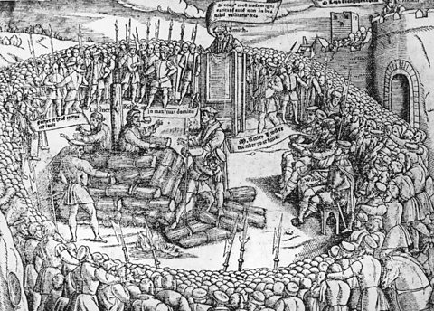

Picture from Foxe's Book of Martyrs. This is one of the most influential and well-known books in history. Copies of the original text (Acts and Monuments) were chained beside the Bible in churches of England and even sailed with English pirates. This was not a book designed to comfort, but instead to present the truth of the persecution faced by Protestant Christians in hostile environments.

**Source 2: An extract from the book ‘A Chronicle of England during the reigns of the Tudors.**

This book is a reproduction of the original book published in 1877. It is a historical work by **Charles Wriothesley**, a 16th-century English herald and chronicler. The first volume, covering the period from **1485 to 1559**, was edited by **William Douglas Hamilton** and published in the 19th century as part of the Camden Society's series.​

**Source 3: A published illustration from a newspaper or book in 1796**

Akenhead and Sons in 1796 were publishers and printers.

**Source 4: A picture of a scold’s bridle owned by the Leeds Museum.**

This particular item was collected by Morley historian Norrison Scatcherd (1780-1853) who left it to the Leeds Museum where it has been in the collection since 1863.