Place Value

1) Draw a line to match

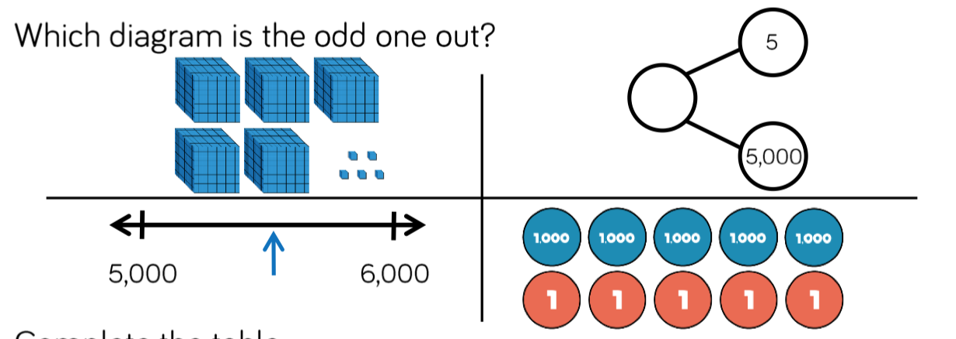2) Circle the o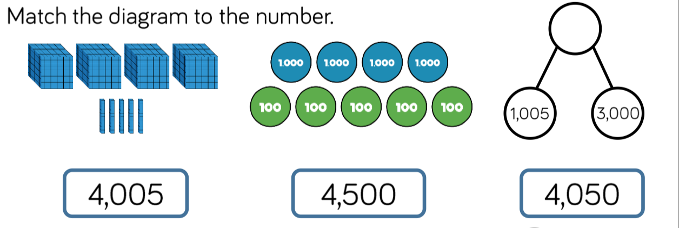dd one out

3) Fill in the spaces in the table

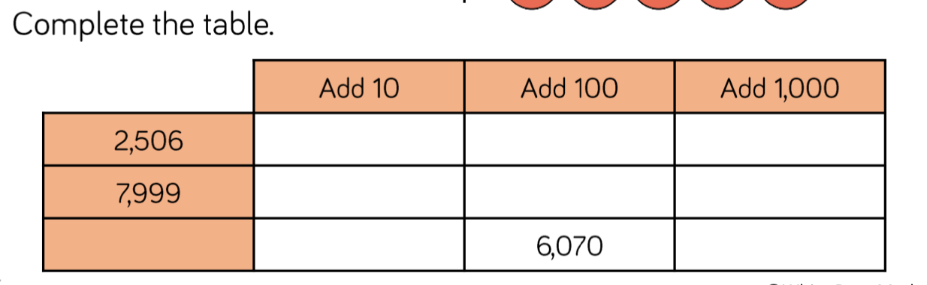

Ordering

4) Read the question. Explain your answer to the right…

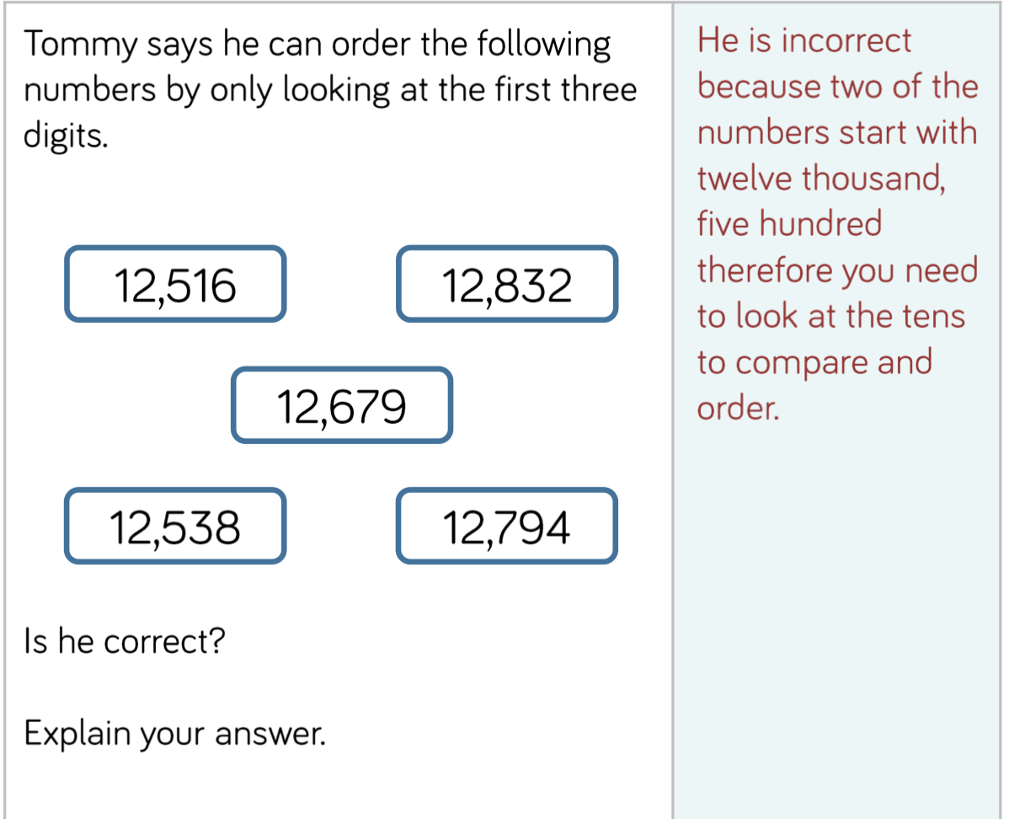

Roman Nume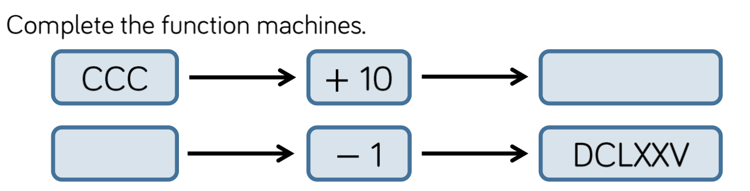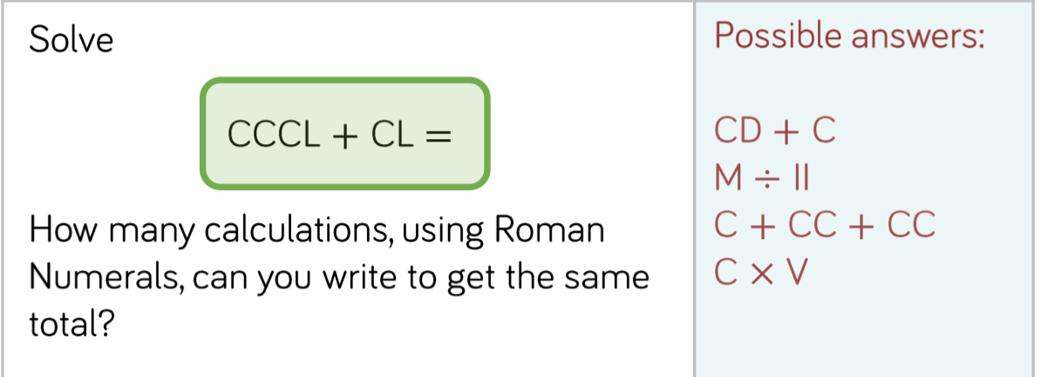rals

5) Use the roman numerals guide poster to help you

6) Show your working out to the right

7)

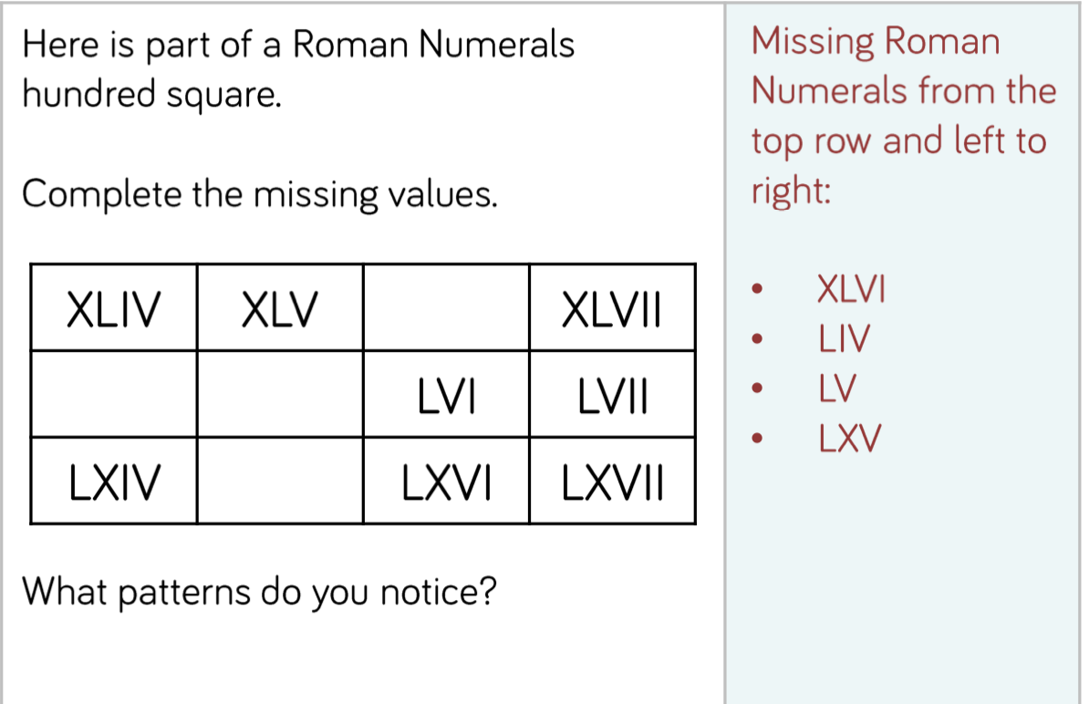

Rounding

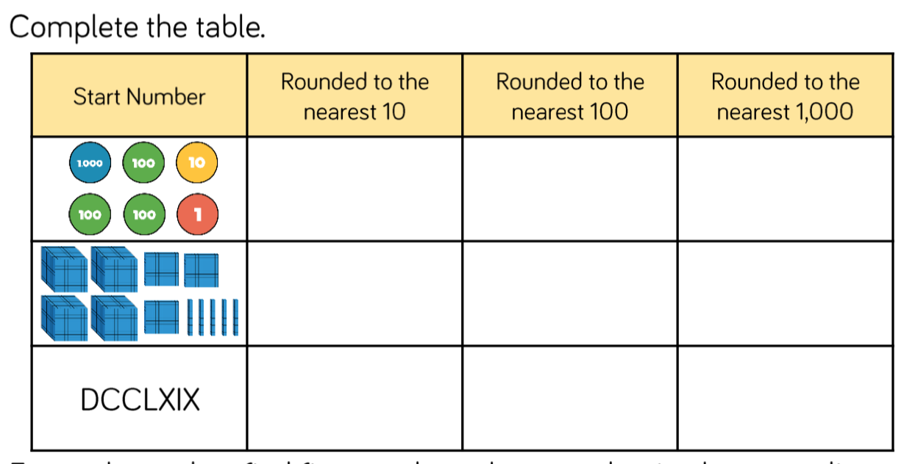8) Complete the table by writing the **numbers** in the correct columns

9)

1. 300 ___________ ____________ __________ ______________ ____________

b) 10,000 ____________ ___________ __________ _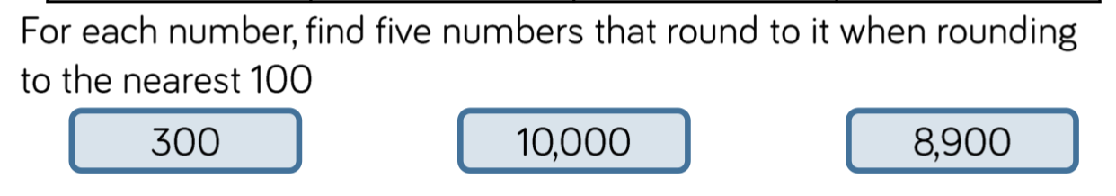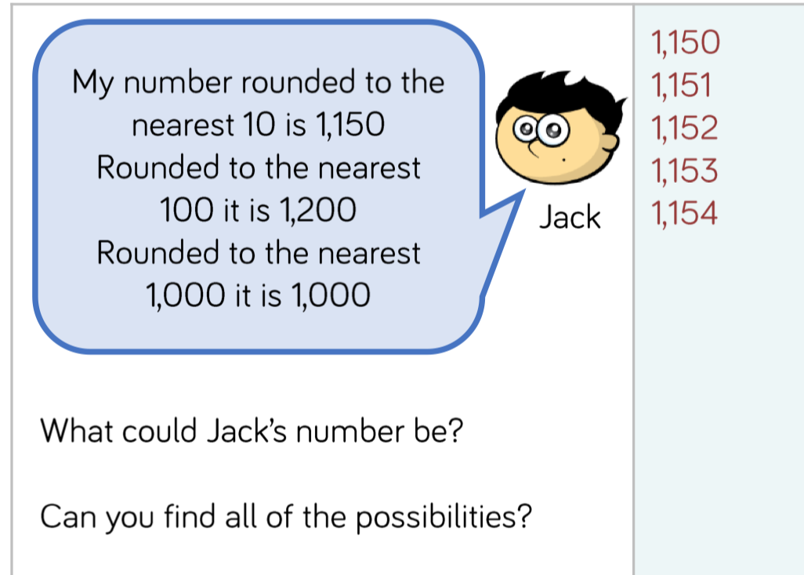__________ ____________

c) 8,900 ____________ __________ ___________ ____________ ____________

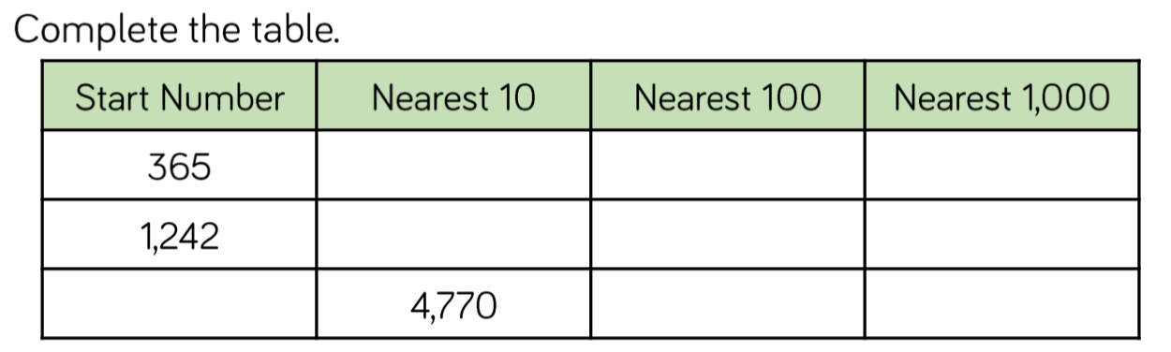10)

11)

Write your answer(s) here:

12) Do you agree? Explain your answers to the right…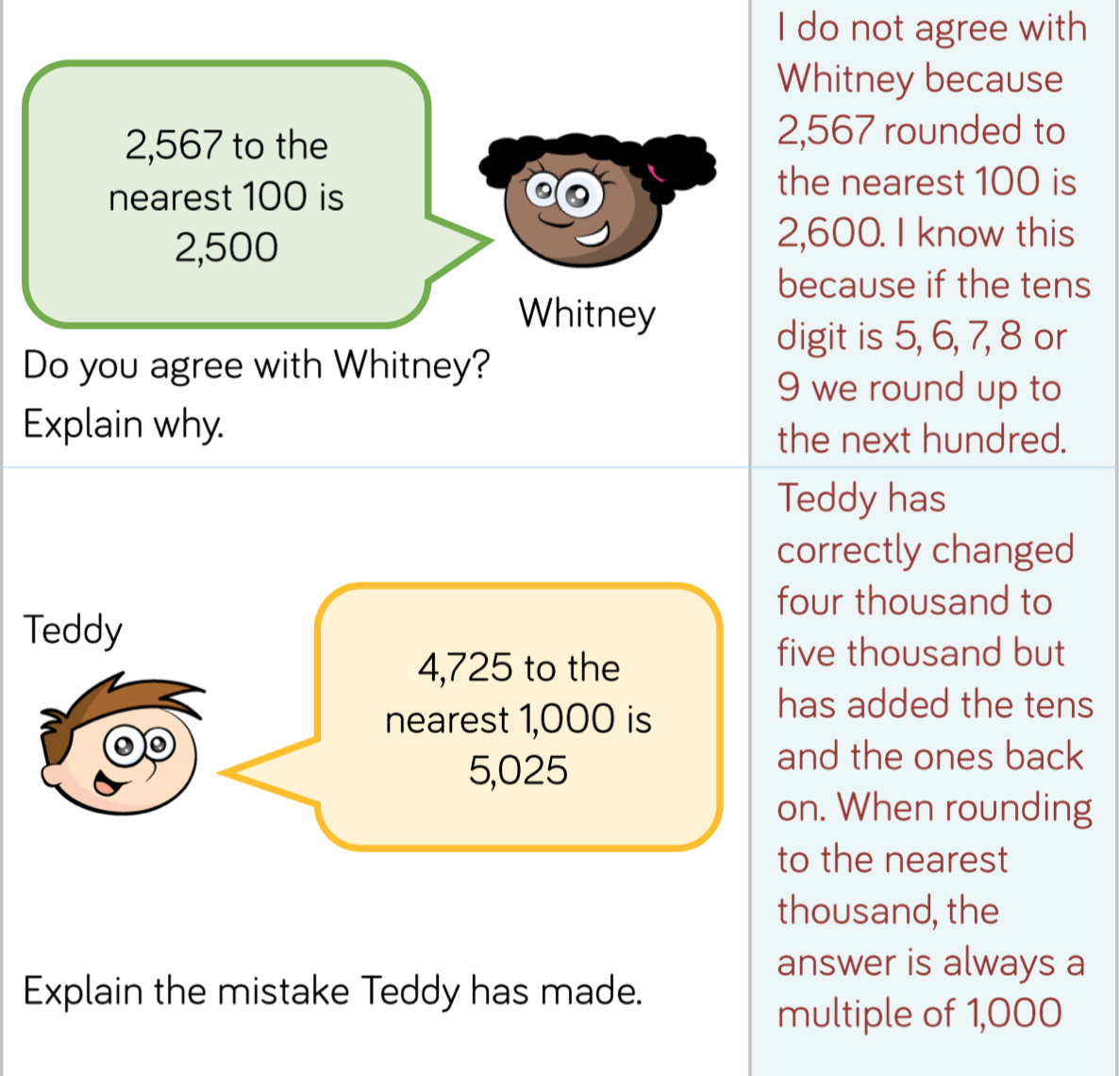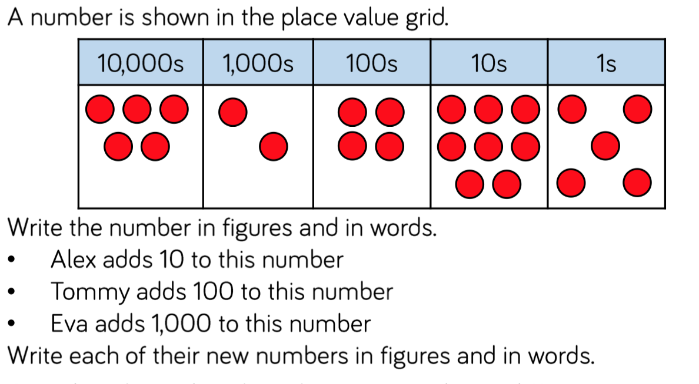

13)

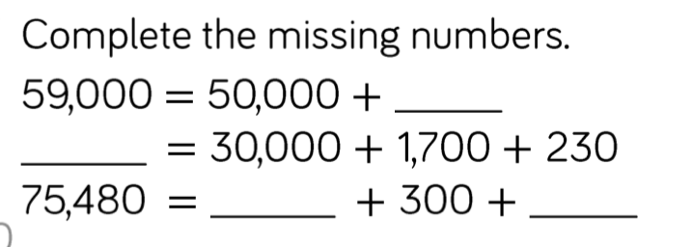

Place Value

14)

15) Write your answers to the right

A =

B=

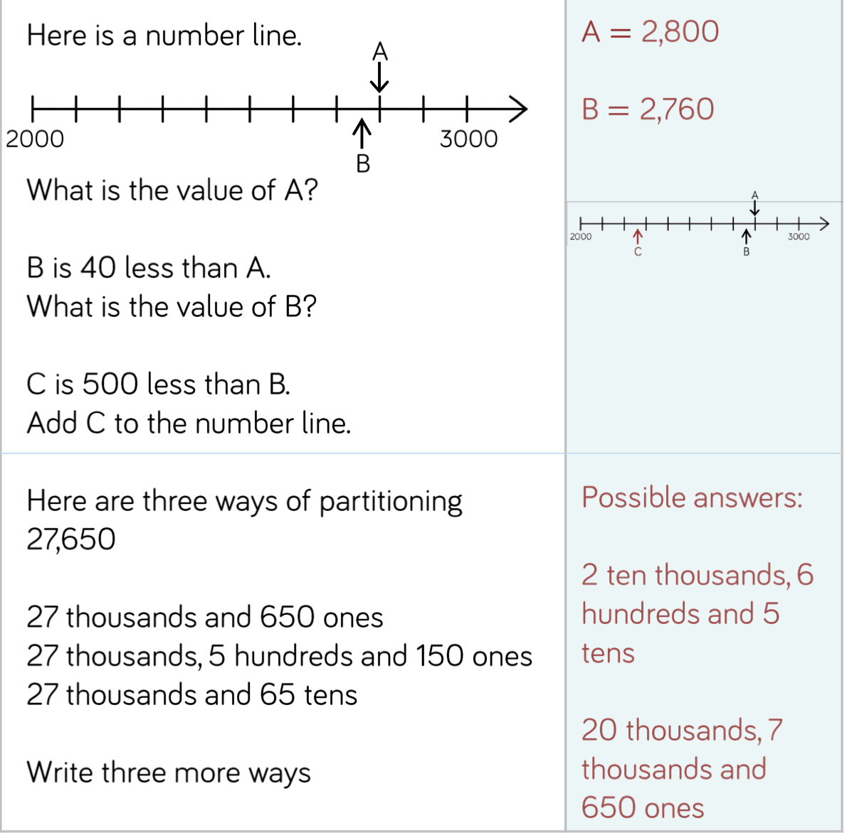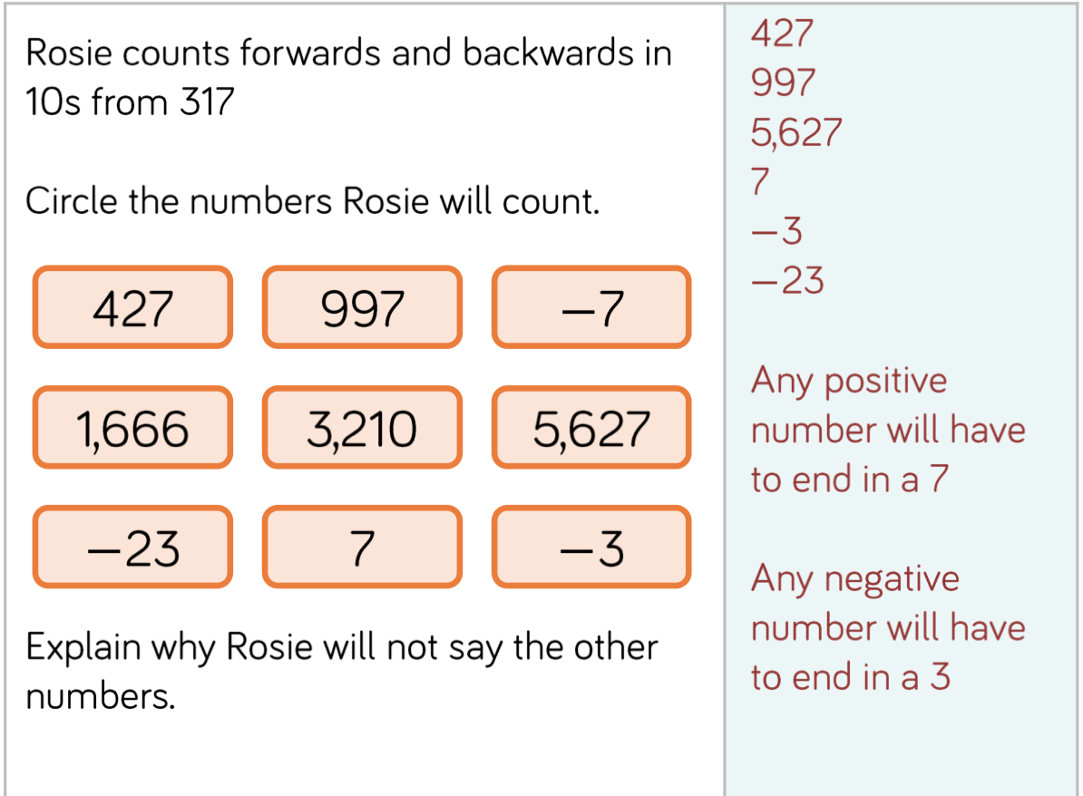

C=

16)

Rosie will not say the other numbers because:

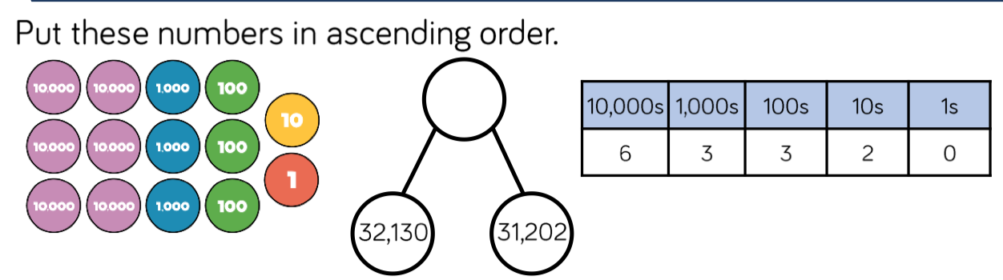17) Write in **ascending** order by putting 1st, 2nd, 3rd by each value

18)

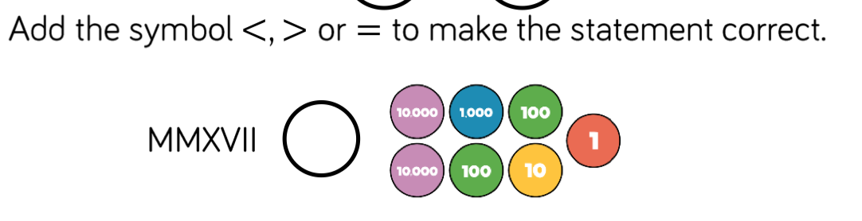

19)

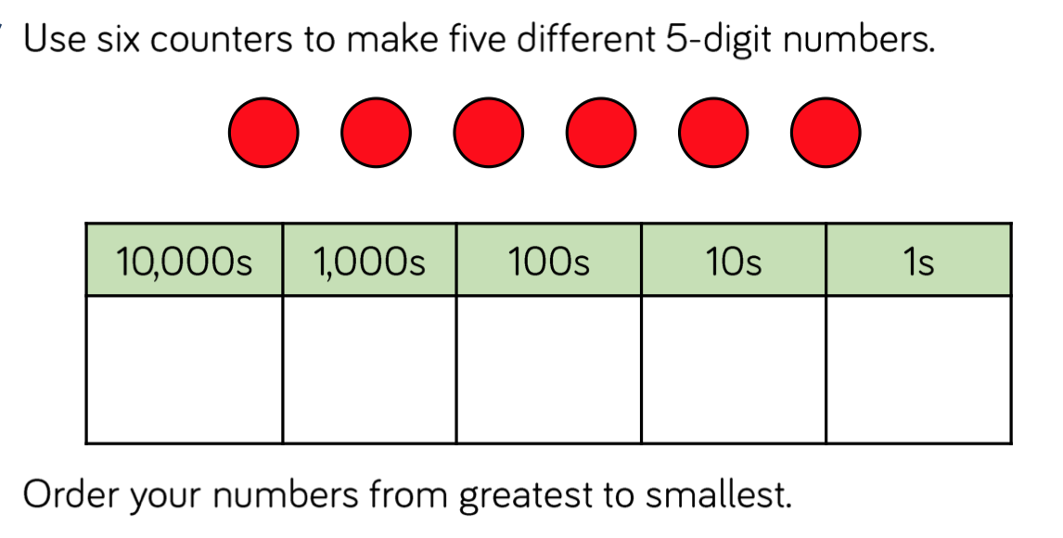

Write your 5 5-digit-numbers here:

Now put them in order, greatest to smallest here

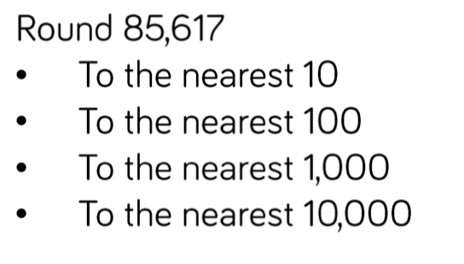

Rounding Write your answers here

20)

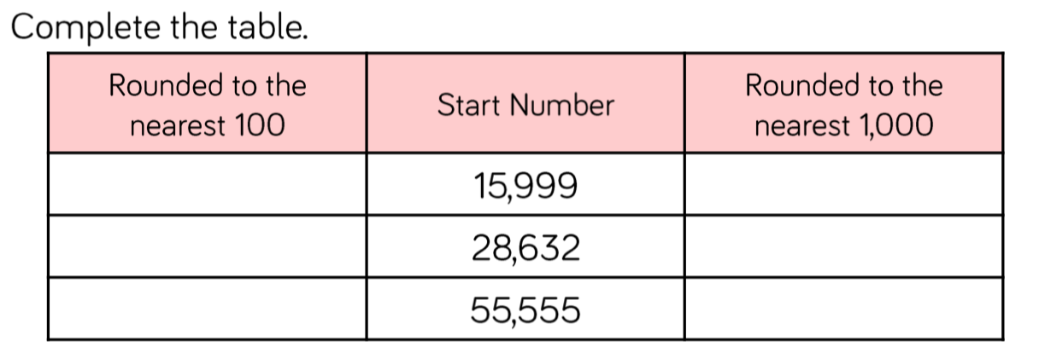2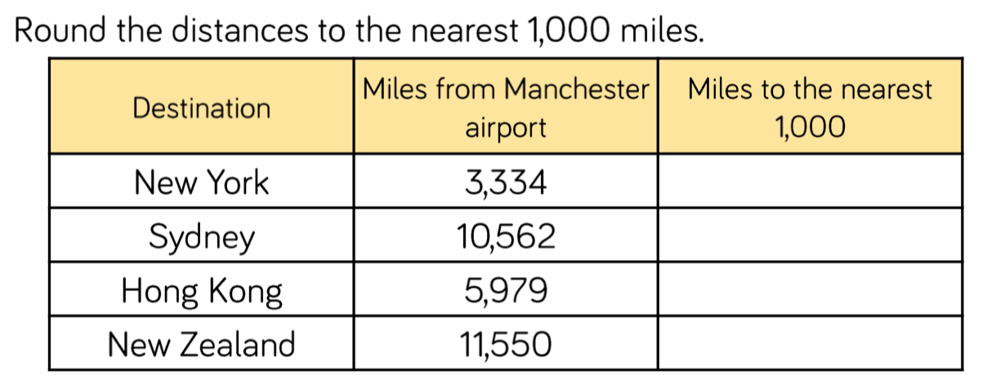1)

22)

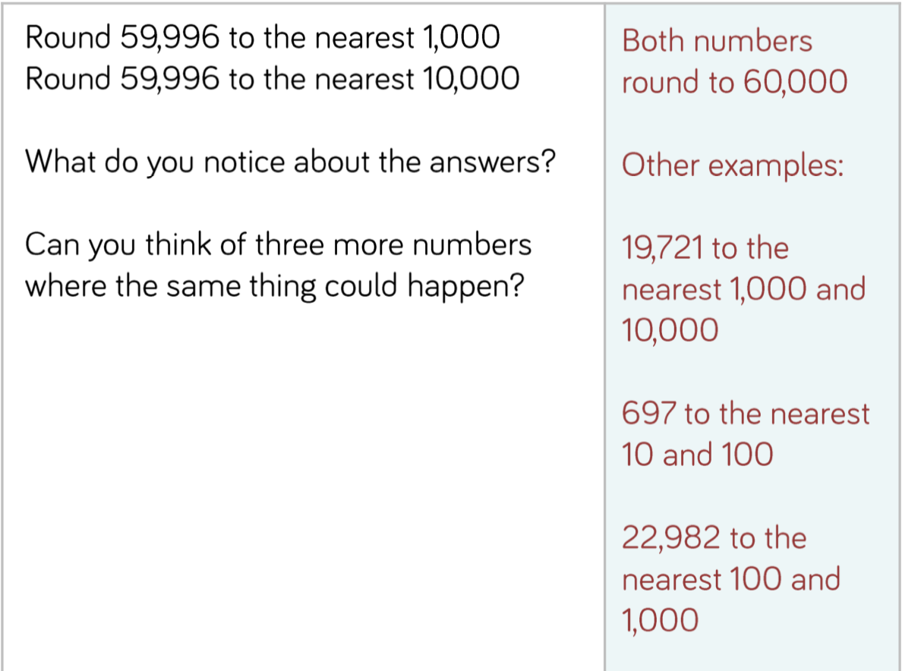 23) Place Value

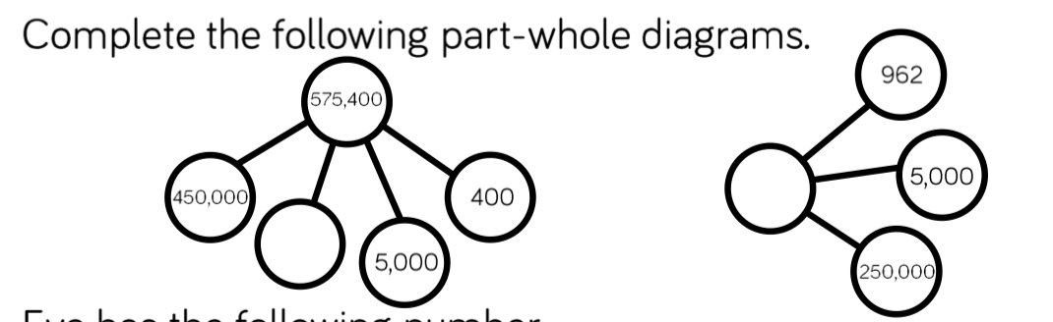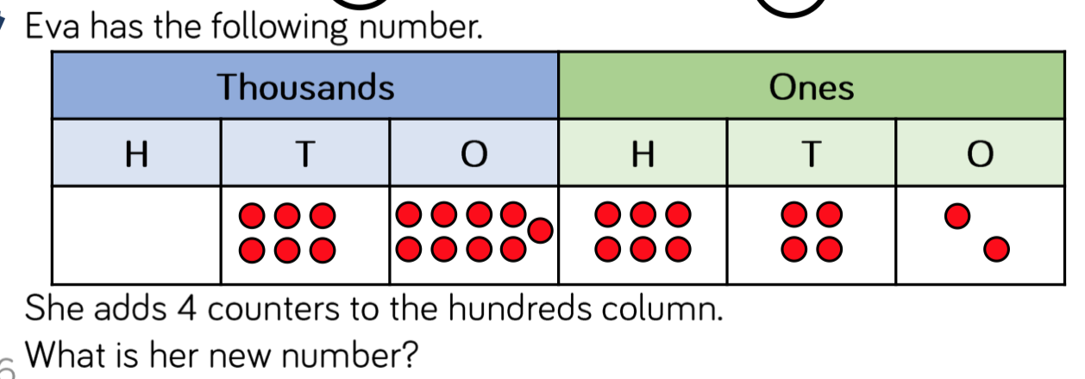24)

25)

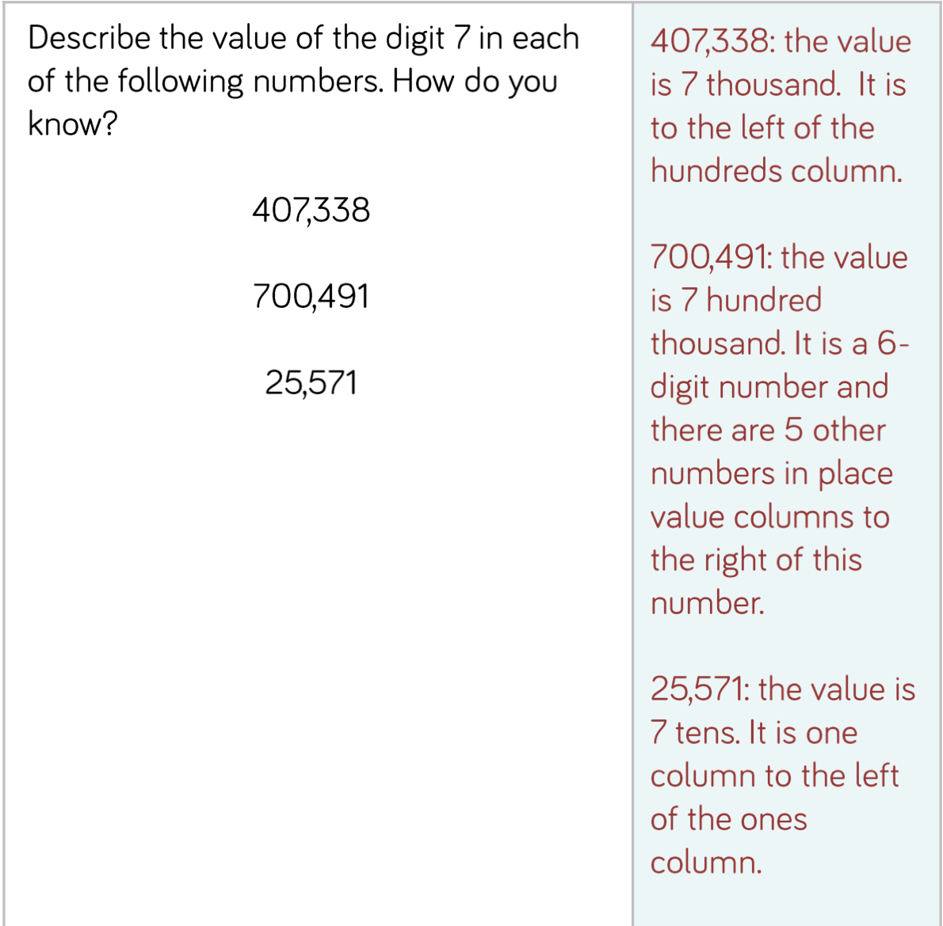26)

27)

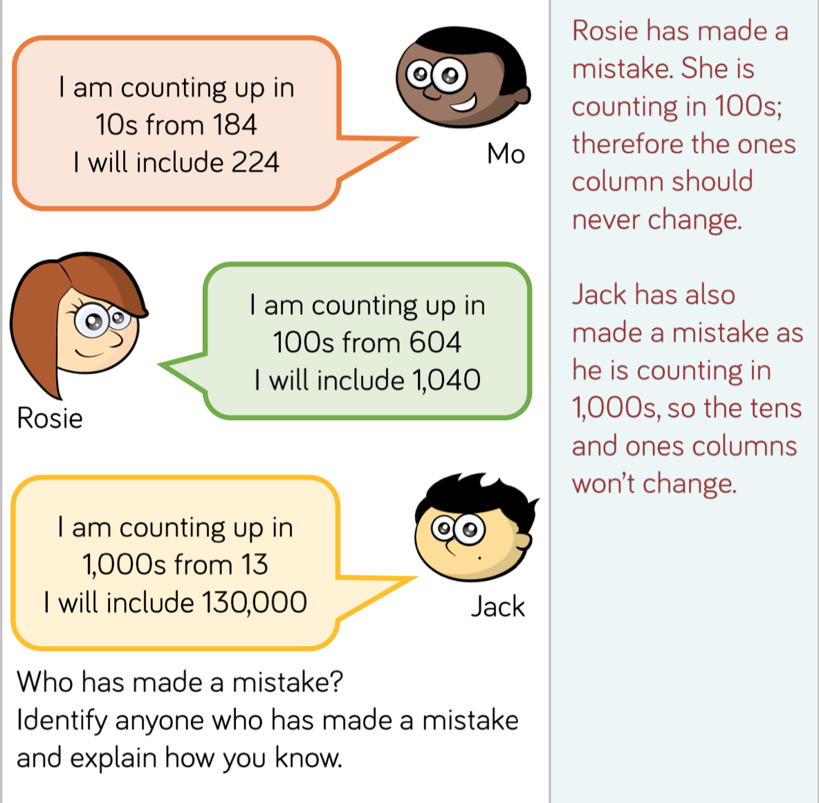

Sequences

28)

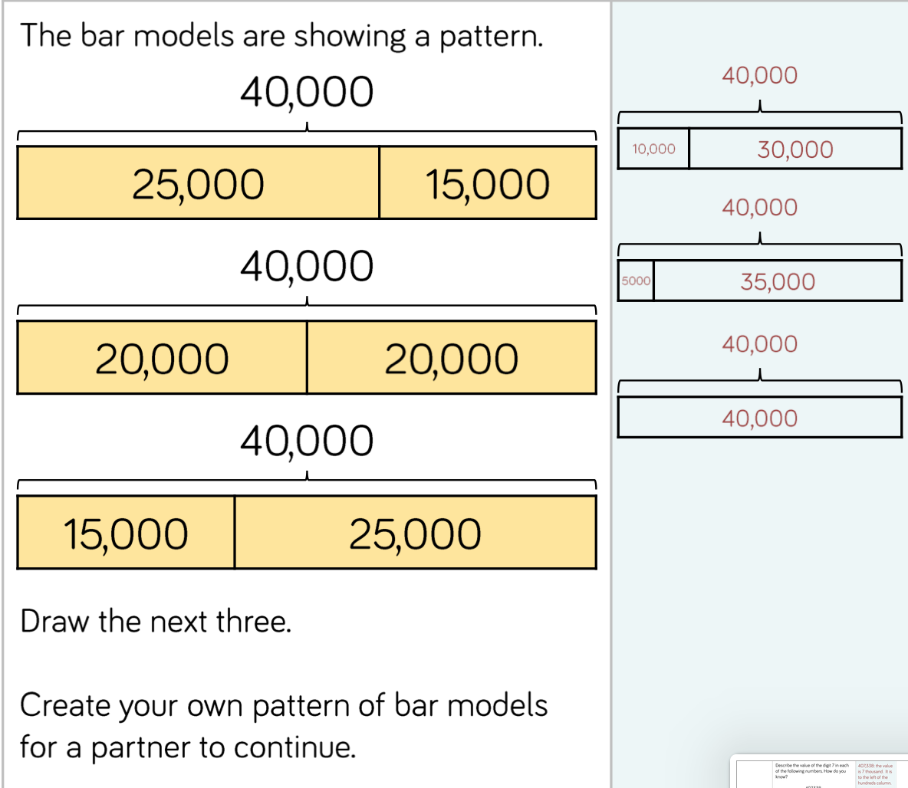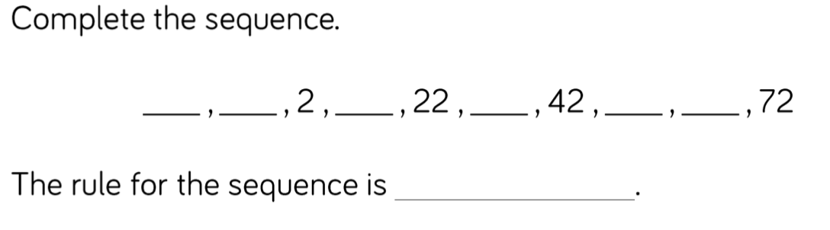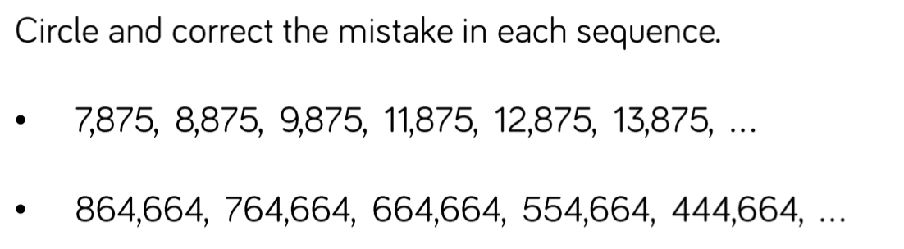

29)

30)

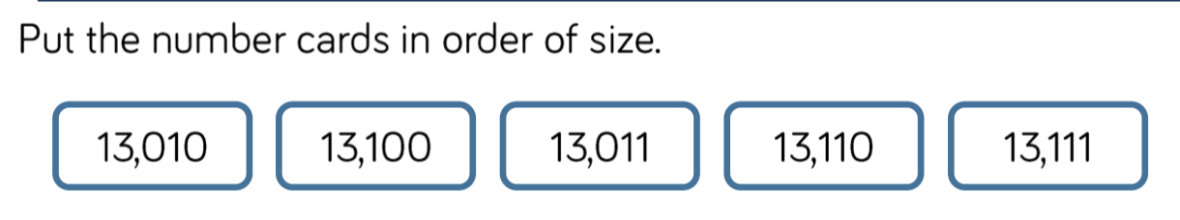31)

Estimation

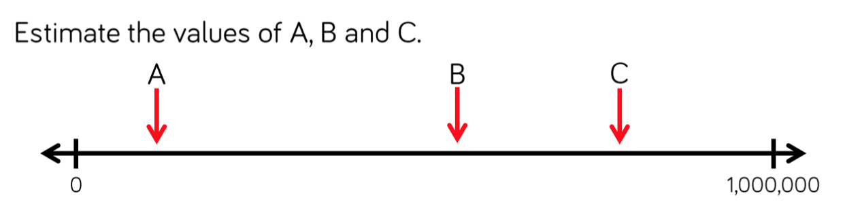32)

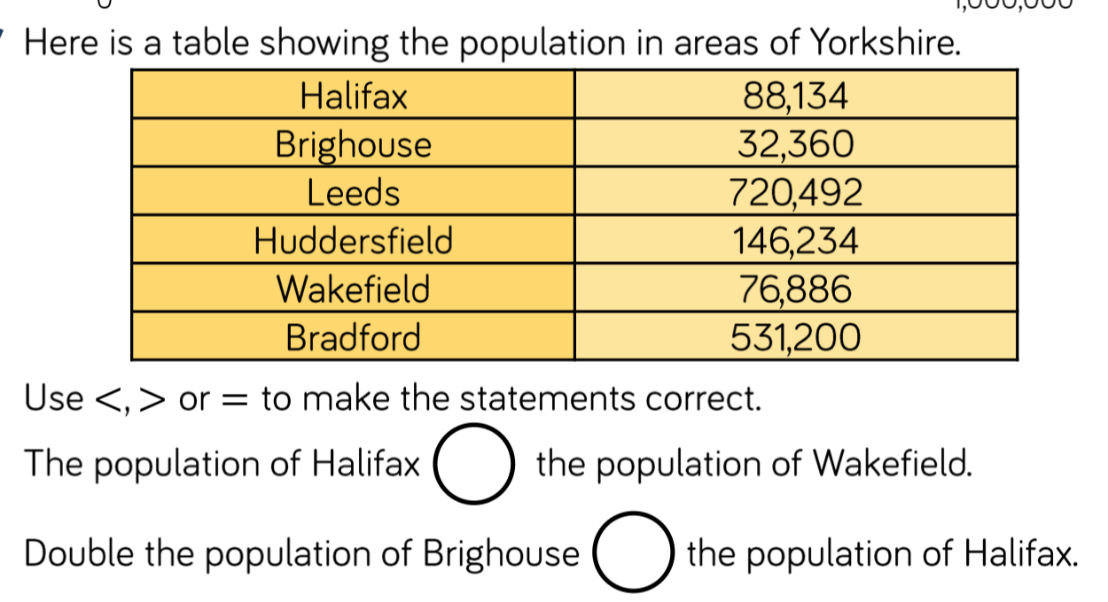

More or less

33)

34)

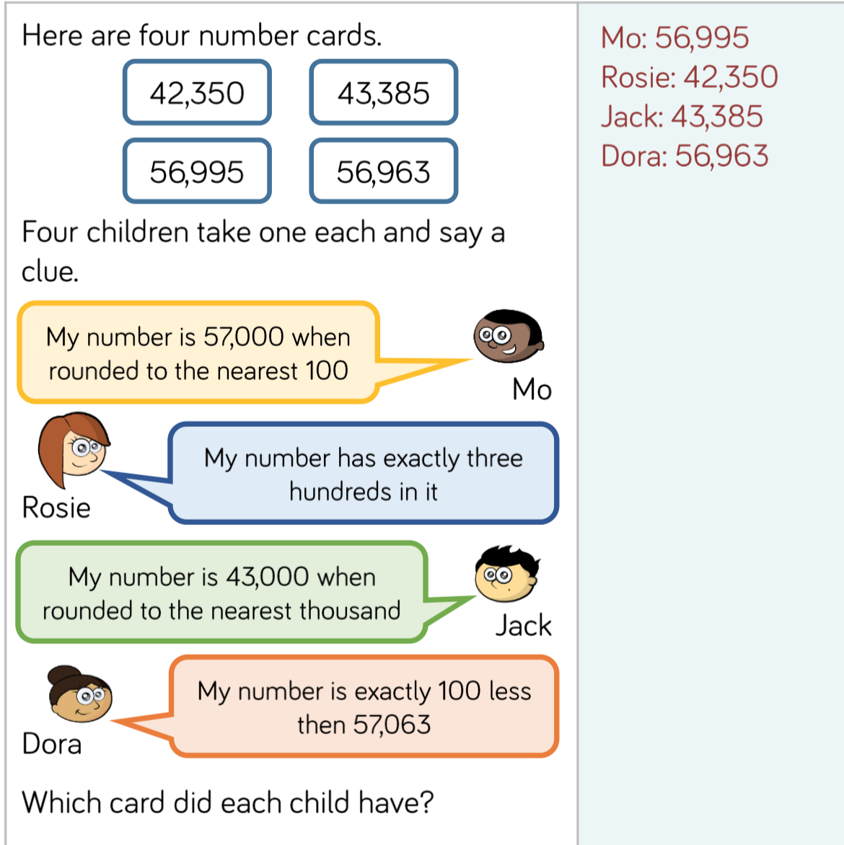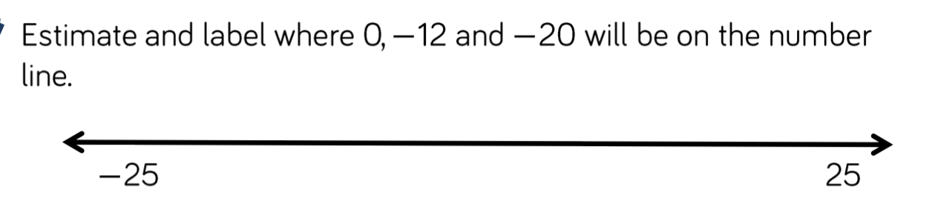

**Mo**

**Rosie**

**Jack**

**Dora**

Negative Numbers

35)

36) Draw your number line here:

37) State true or false and give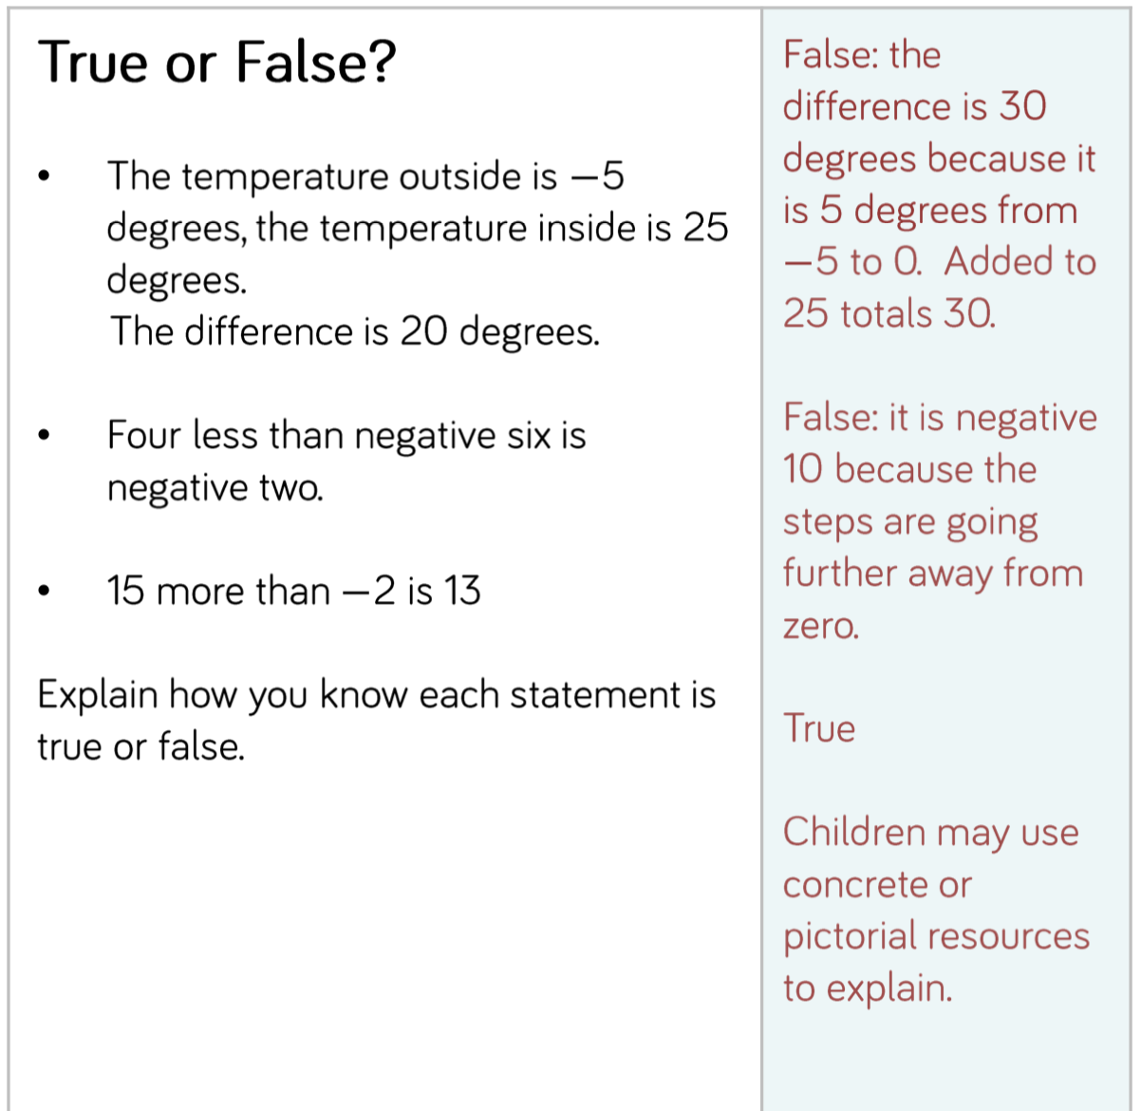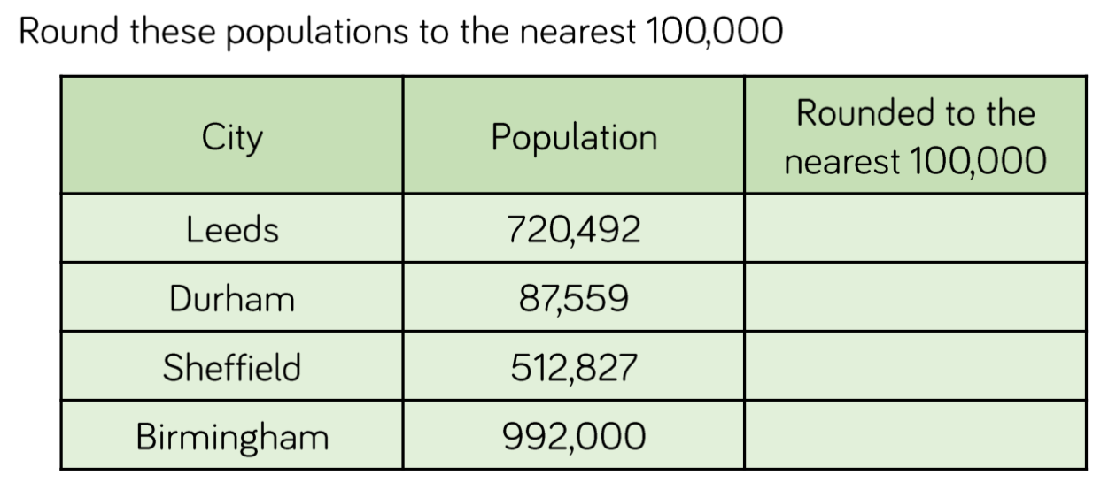 your reasons to the right

Rounding

38)

39)

40)

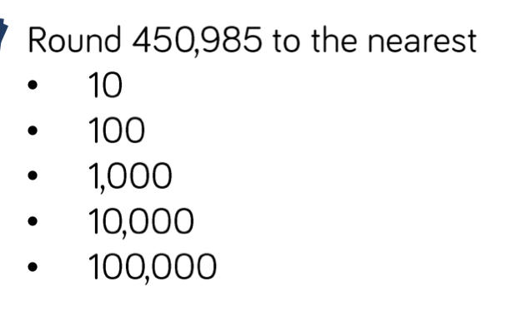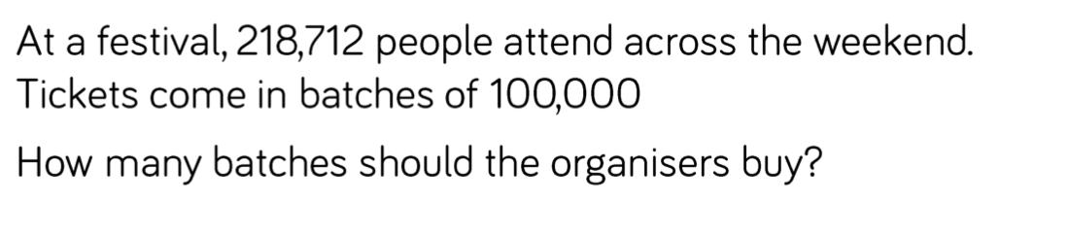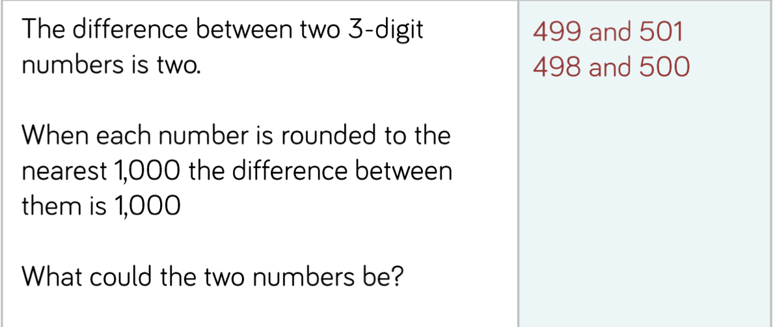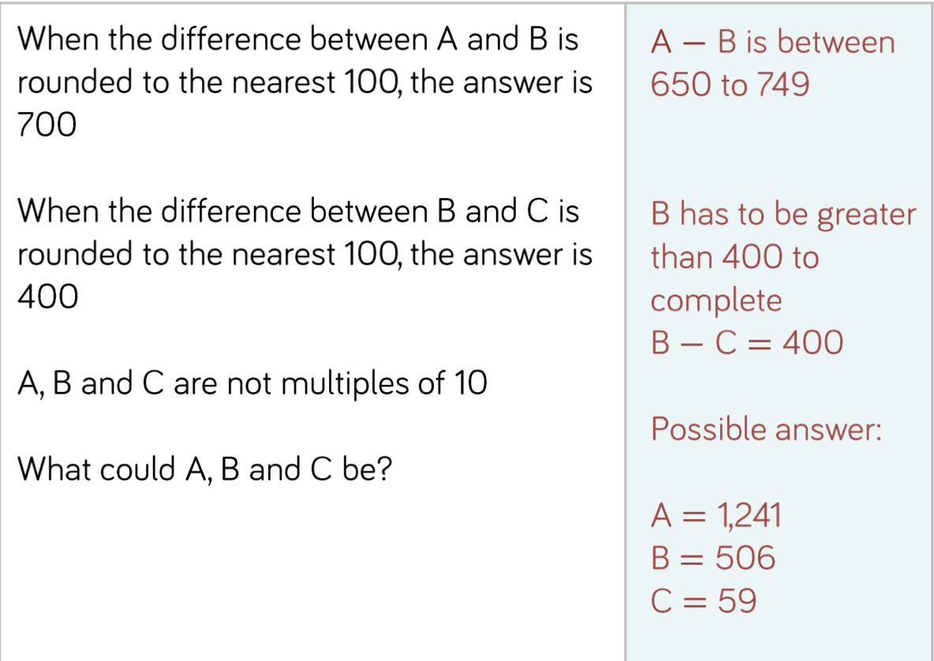

41)

42)