My family history project - Dedicated to my Great Grandfather Mr Gordhan Das Jetha Bhai Chatralia – by Arjun Bhatt (5W)

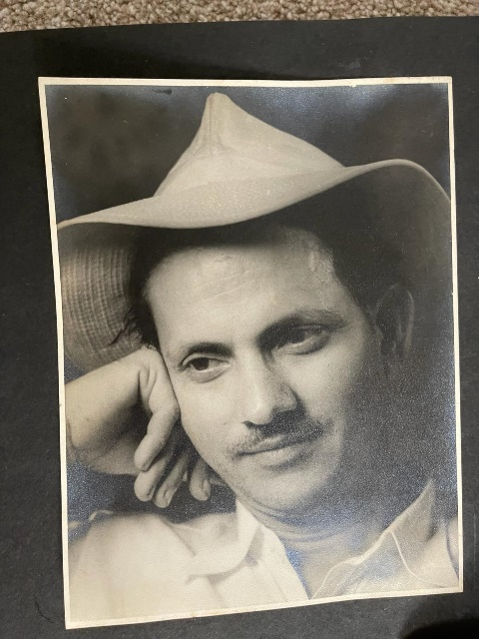
My great grandfather Gordhan Das Jetha Bhai Chatralia was born in 1915 in a small town called Shiva in India. We fondly call him Bapuji. His father, my great, great grandfather Jetha Bhai Chatralia lived in Africa. He worked as a carpenter under the German government during the 2nd World War. Bapuji moved to Africa when he was 12 years old and went to school to study which they called metrics until the 12th standard. For his evening job he worked as a film operator in the cinema hall at the Odean cinema in Dar-e-salaam the man city of Tanganyika. Fun fact!! I have been told that Bapuji used to often fall asleep during the film and the audience would wake him up to change the next reel. Back in those days films were put onto reels and 1 film could have up to 8-10 or more reels.
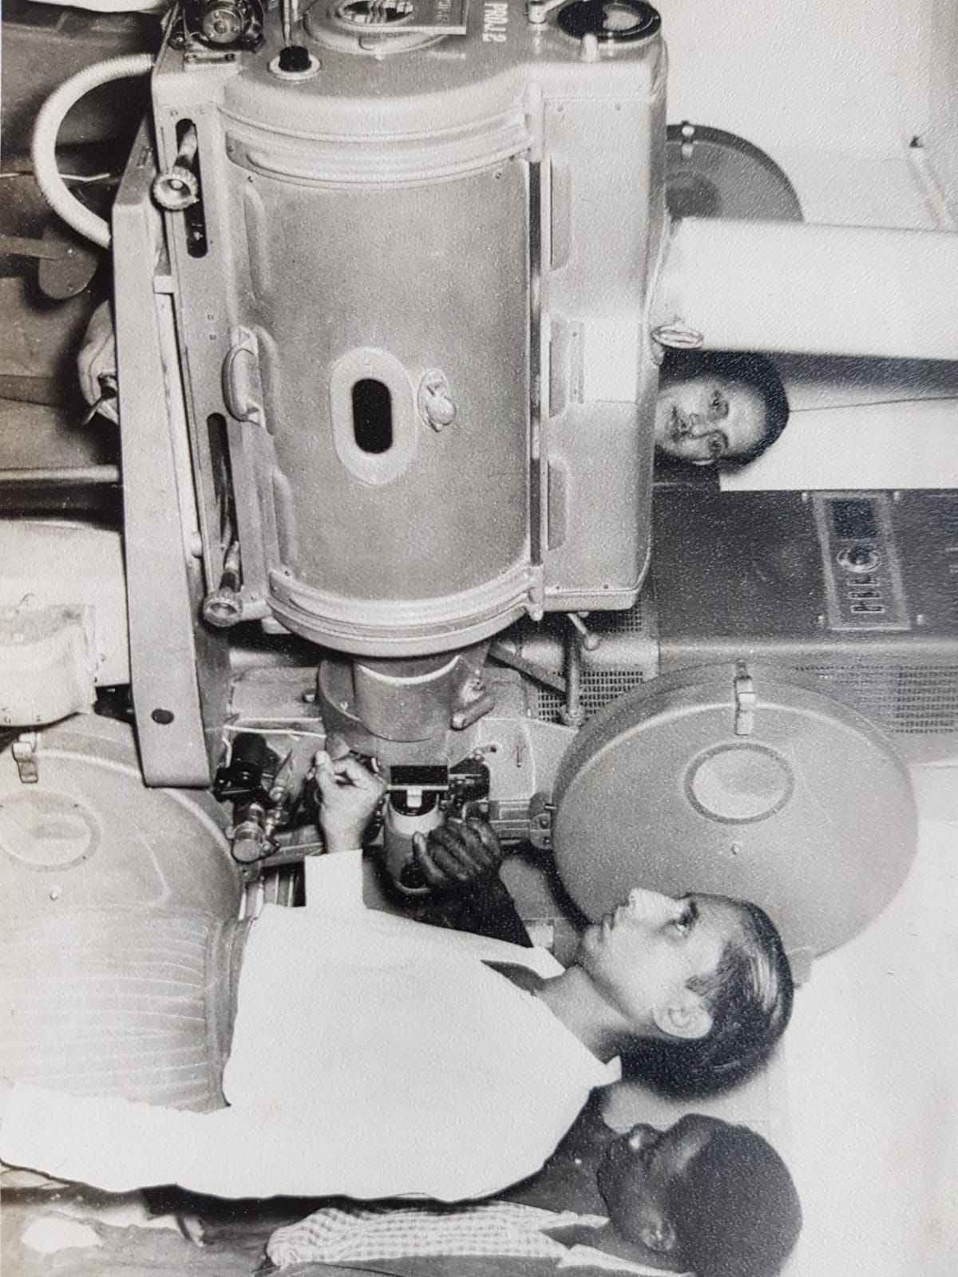

In 1934 Bapuji travelled to India and during 1936 to 1945 he worked at the palace in Jamnagar for King Jam Sahib Bapu where his job was to repair all the clocks in the palace including the wall clocks and the tall grandfather clocks which needed winding up every 8 days. While he was at the palace he played with the prince who was 3 years old. The palace was called Pratab Villas.

In 1940 he married my great grandmother, and they lived in India for a long time and in 1948 they returned back to east Africa - Tanganyika.

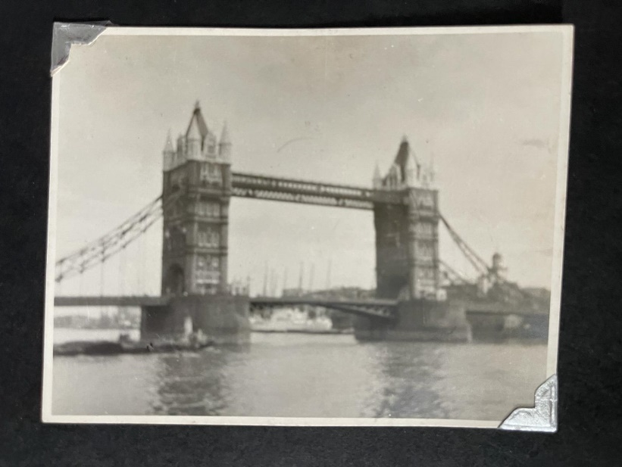
In 1957 the company Bapuji was working for sent him to England for further studies for 6 months. Where he trained on an Adding machine and studied as a technical engineer in London. Bapuji took 9 exams and achieved a first class in all the exams and then went back to Tanganyika. He was very clever and talented.
Here are pictures of Bapuji’s trip to London:
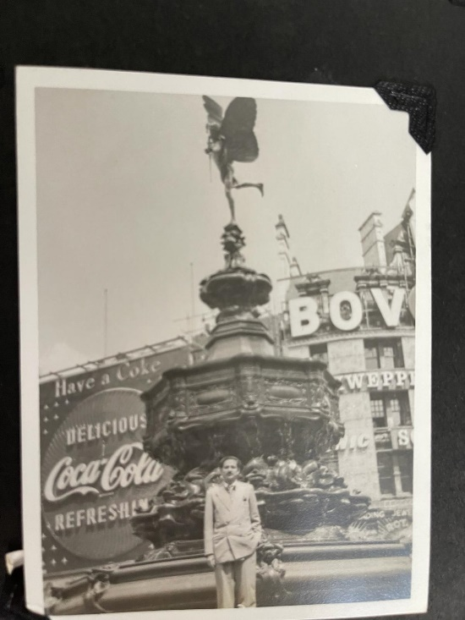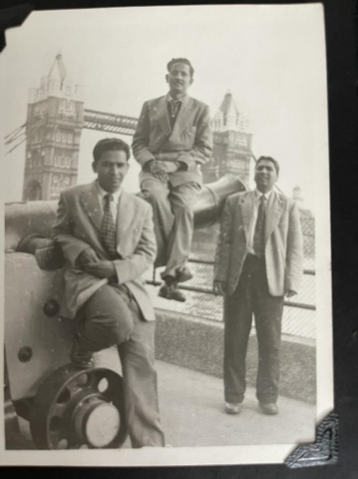
In 1962, Africa gained independence from the British and Tanganyika became Tanzania. In 1977 as he had a British passport the Tanzanian government did not allow British subjects to work there, he decided to move to England with his wife and 2 children - my great aunt and grandmother) and then retired in England.

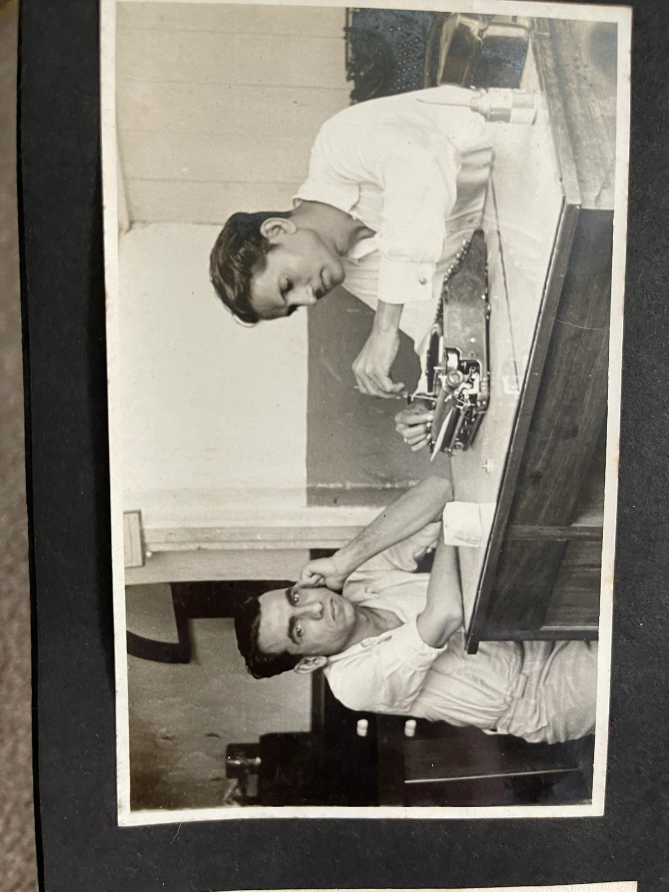
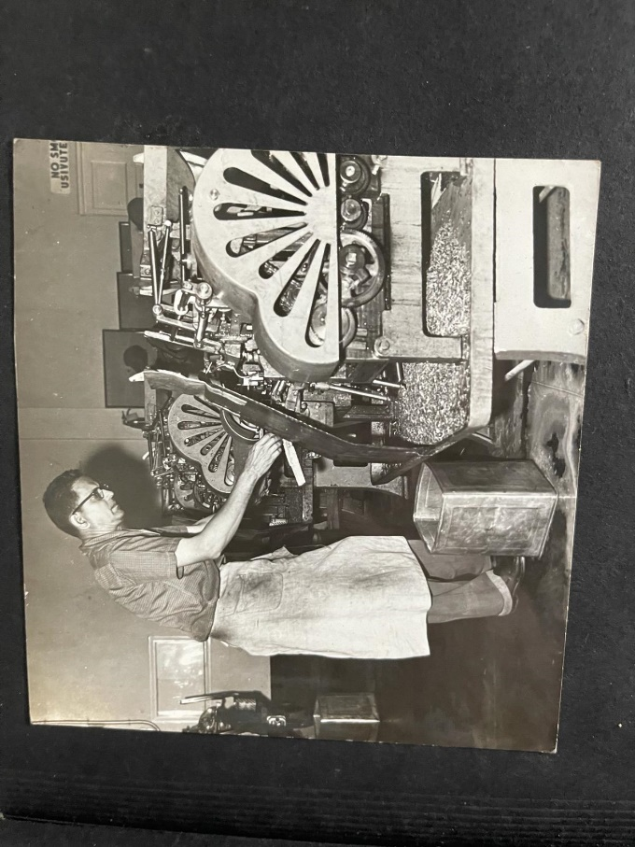
During Bapuji’s retirement he had many holidays in Europe with the seniors citizens group, his favourite was brussels. Bapuji was very jolly, fit and an energetic person he knew many languages including Hindi, Urdu, Swahili, English and many dialects of Gujarati. Fun Fact!! He even learnt some Japanese in 1965 to 69 where he worked at a screw factory trained by a Japan trainer and his photo appeared in the Sunday times newspaper. Bapuji was very famous all-around Tanzania and could repair any machine he was even sent to the banks to fix their machines.
Bapuji even was requested by Williamson and Diamond mine in Tanzania many times to repair machines deep underground. Often on his exit he would be checked to make sure no diamonds were stolen . He enjoyed his life very well and did many travels to India in the second class cabin see timeline below:

Dar – e - salaam
Seychelles Island
Bombasa (a Port in Kenya)
Zanzibar

Bombay (now called Mumbai)

15 Days by Ship

Here is my family tree written in Gujarati created by my Grandfather Mansukhlal Bhagwanji Gorecha:
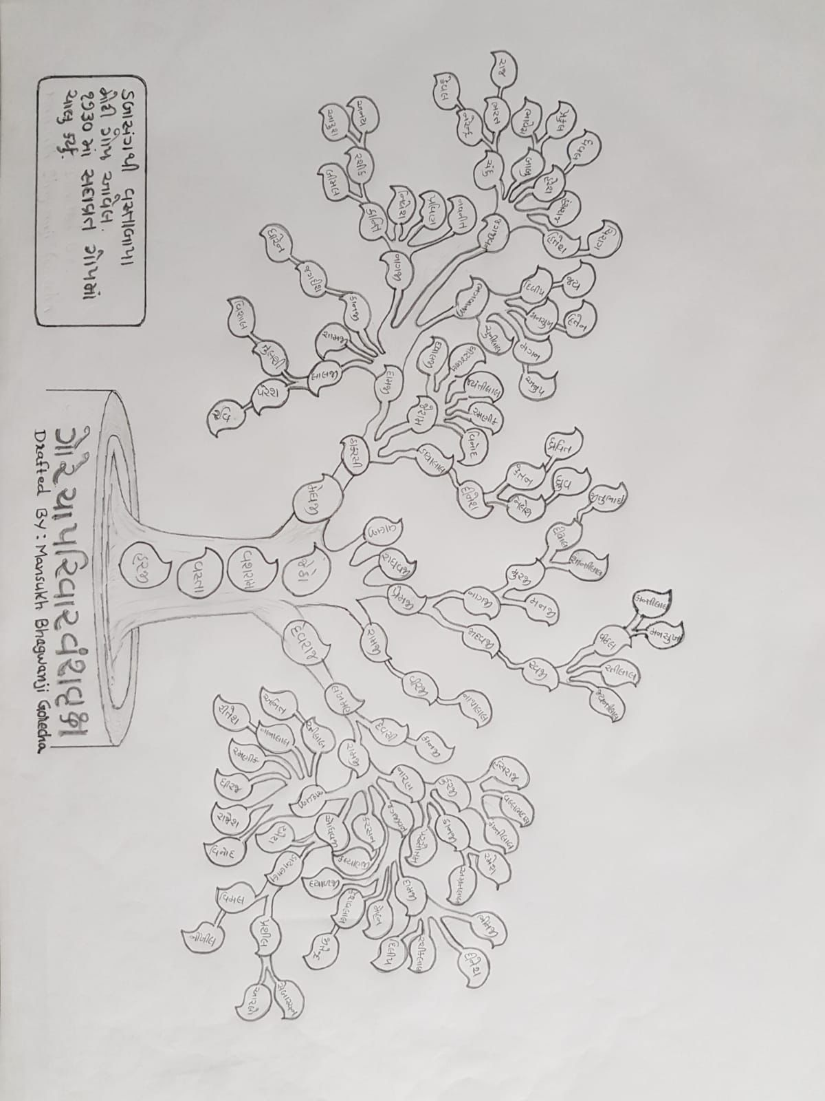
I hope you have enjoyed reading about my Bapuji and his amazing life. Special thank you to my great Aunt for all the stories and to my aunt and uncle for the pictures.
Arjun Bhatt
5W

