Guru  Sikhism: The importance of the ten Gurus | When were they born? What did they give to Sikhism? What was special about them?
  Guru Nanak Dev | Guru Nanak was born in Nankana Sahib (Pakistan) on October 20 1469. At the age of 30, Guru Nanak was the first Guru because he founded the Sikh religion. He introduced the idea of there being just one God. He died in Kartarpur on September 7 1539, aged 70.
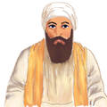
Guru Angad Dev
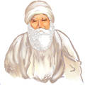
Guru Amar Das

Guru Raam Das
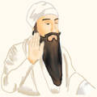
Guru Arjan Dev
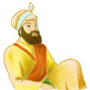
Guru Har Govind
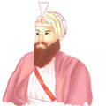
Guru Har Rai

Guru Har Krishan

Guru Teg Bahadar
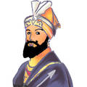
Guru Gobind Singh

