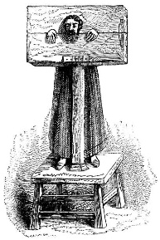  Stocks or Pillory  Accused is locked in wooden boards so people can see and shame them. People may throw rotten food at them. | 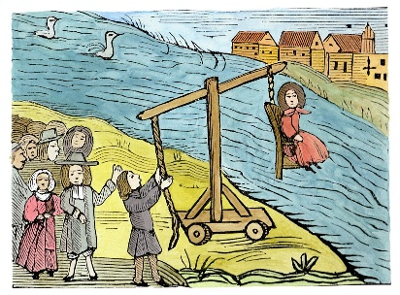  Ducking Stool  Accused is tied to a chair and dunked into cold water for causing trouble.
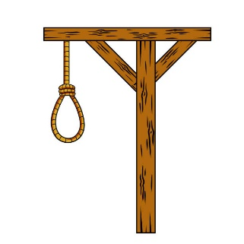  Hanging  A serious punishment where the accused is put to death by a rope. | 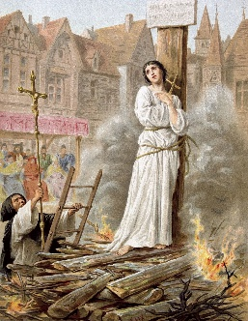  Burning at the Stake  The accused is tied up and set on fire.
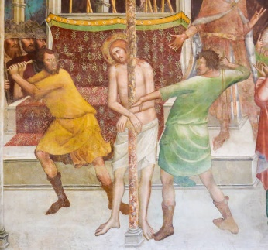  Whipping  The accused is hit with a whip to cause pain as punishment. | 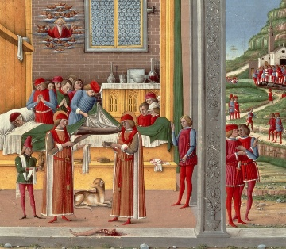  Amputation  A body part like a hand is cut off to stop someone from stealing again.
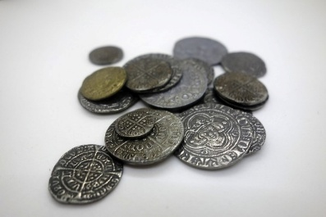  Fines  The accused has to pay money as punishment for their crime | 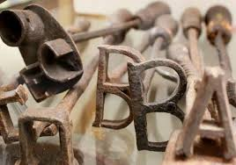  Branding  A hot iron is used to burn a mark into the skin to show they did wrong.
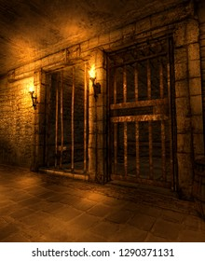  Imprisonment in a Dungeon  The accused is locked up for a time as punishment or before trial. | 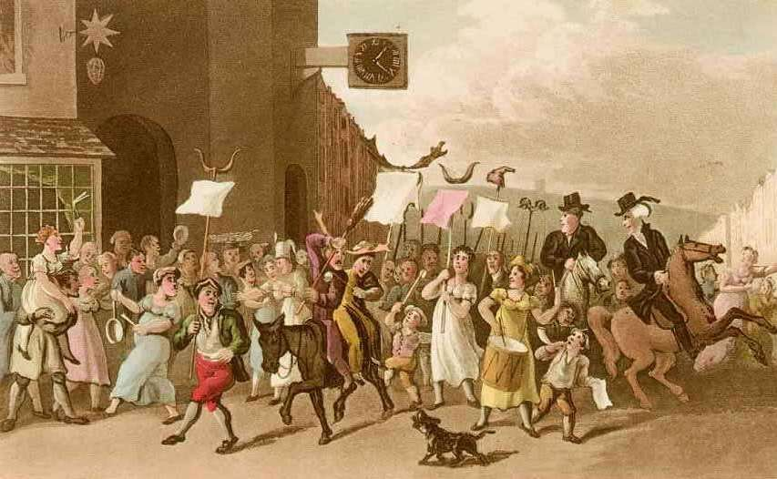  Public Shaming  The accused is made to walk in front of others to feel embarrassed.

