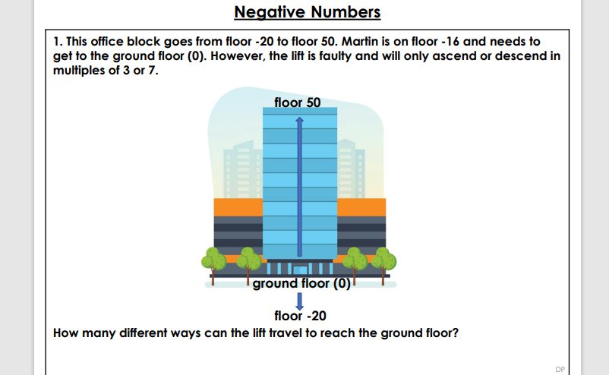

How can you solve this?

* Show all your working and do not cross/rub out if it’s wrong-it’s all part of the solution.
* If you make a mistake, try again!
* You may want to draw a number line as Martin has to get to the ground floor but may have to go past it first and then back down! (big clue).
* **Extension**-is there more than one way for him to do it?
* Which is the longest/shortest route?