MOON PHASES

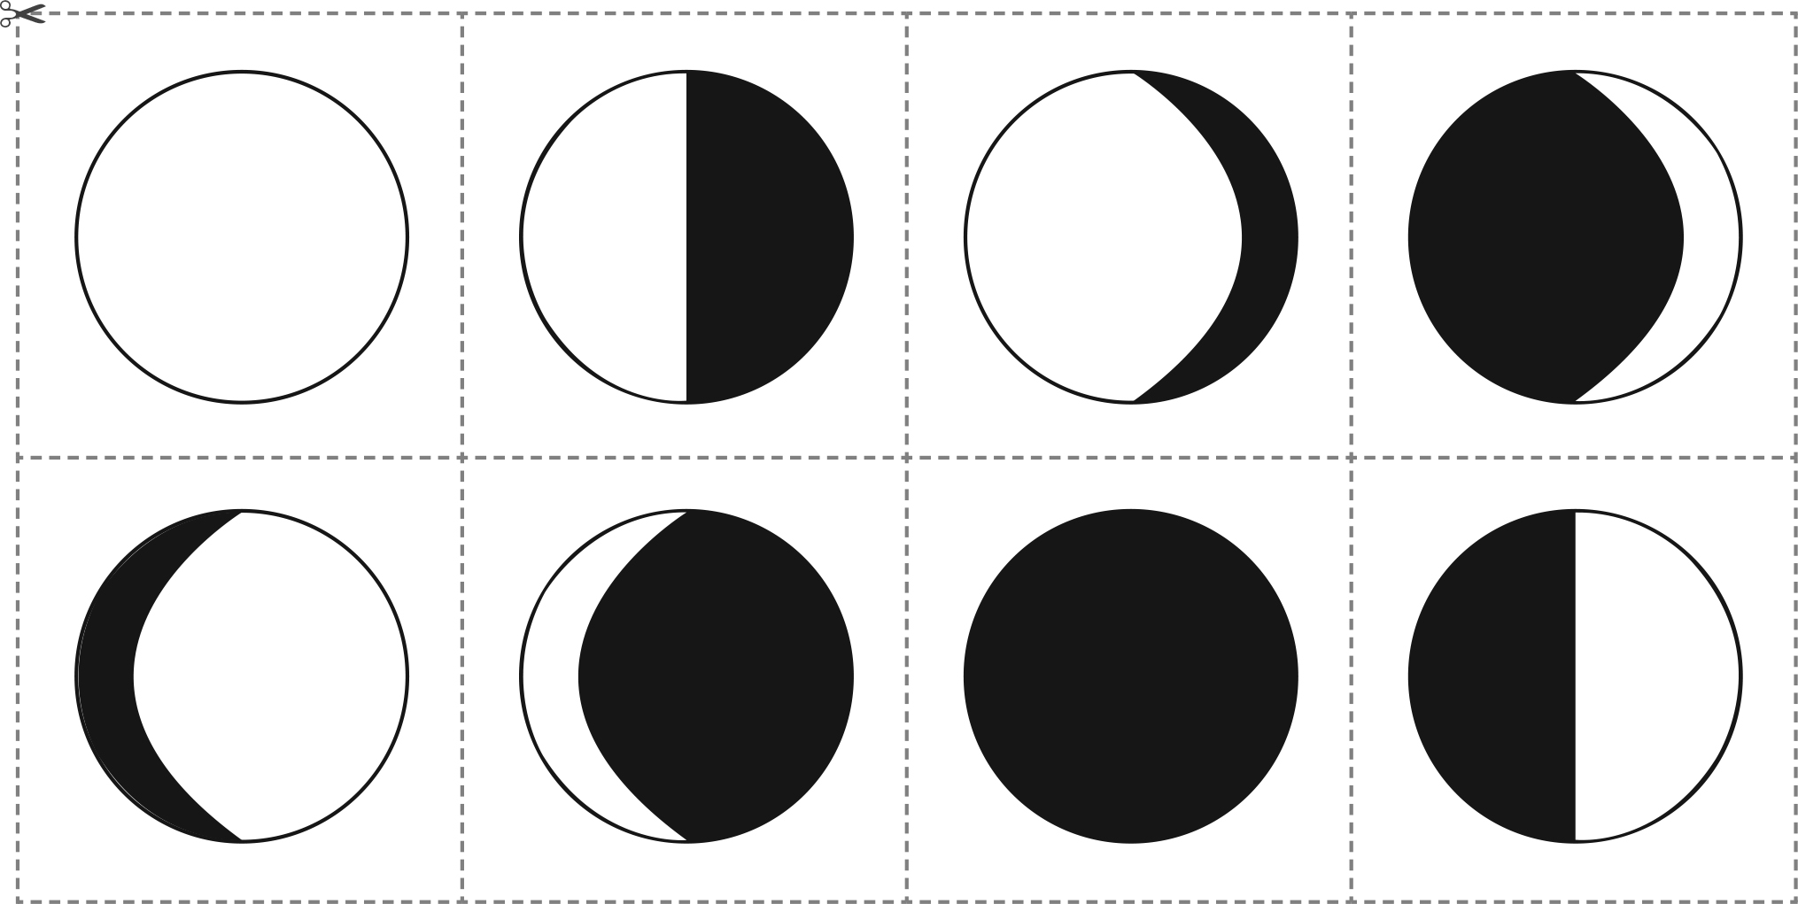

|  |  |  |  |
| --- | --- | --- | --- |
| New Moon | Waxing crescent | First quarter | Waxing gibbous |
| Full Moon | Waning gibbous | Third quarter | Waning crescent |